Microsoft Word:
Mail Merge
June 19, 2019

What is Mail Merge?
Mail merge is a way of placing data from a spreadsheet, database, or table into a Microsoft Word document. It is a way of creating personalized form letters or labels very quickly, without having to edit the original letter several times for different personalized information.
Word’s mail merge feature can be used for more than just creating personalized letters. It can be used to create mailing labels, name tags for an event, or file folder labels. In this session participants will learn all about mail merges using data files created in both Word and Excel.
During this webinar participants will learn:

how to create a data source in Word and Excel

how to create a form letter and merge with a data source

how to create labels and merge with a data source

how to format fields to avoid mail merge format problems with dates and numbers

how to filter and sort the recipient list and merge only to records that meet specific criteria

how to set merge conditions so certain text displays for a specific scenario or condition.
Create the Data Source
Using a Micosoft Word Table

Organize data neatly into rows and columns using Word’s Table feature. Think of each row as a single record and each column a field that will be inserted into the document. The first row contains labels that identify the data. Later when the data is being merged, the labels will appear as the names of the merge fields.

Click the Insert tab followed by Table and drag the mouse over the grid until you highlight the number of columns you want. The number of rows highlighted does not need to be exact as you can easily add rows as you type in the information.
- Note: You will notice there is only an allotment of 10 columns. If you need more click Insert Table and fill in the desired number of columns. When using Word as a data source the number of fields or columns is limited to 62.

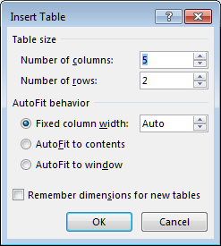

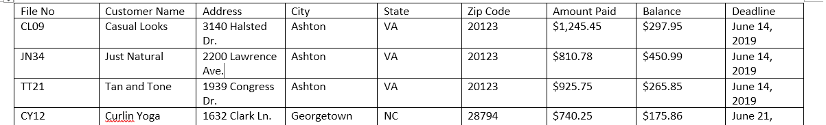

Enter the information by typing File No in the first cell and then press the Tab key to get to the next column. Continue from cell to cell until you get to the end of the first row. Pressing Tab should then take you to the next row.

Adjust the column widths and format as desired. You can also change the page orientation as needed to allow for more room to widen the columns.

Save the file when complete.
Using a Microsoft Excel Spreadsheet

The data source can also be set up as an Excel spreadsheet. The main advantage of doing this is that Excel will allow for 255 columns compared to 62 in Word.
- To make it easier to identify the data when attaching to Word, rename the worksheet by right-clicking on the name of the sheet (i.e. Sheet 1) and choosing Rename.
- Enter the data in similar fashion to Microsoft Word, adjusting column widths and formatting as desired.
- Save the file when complete.
- Delete all other worksheets by right-clicking on the worksheet name and choosing Delete.

Setup the Main Document
For the main document, you can use either a new, blank document, or a document you've already created.
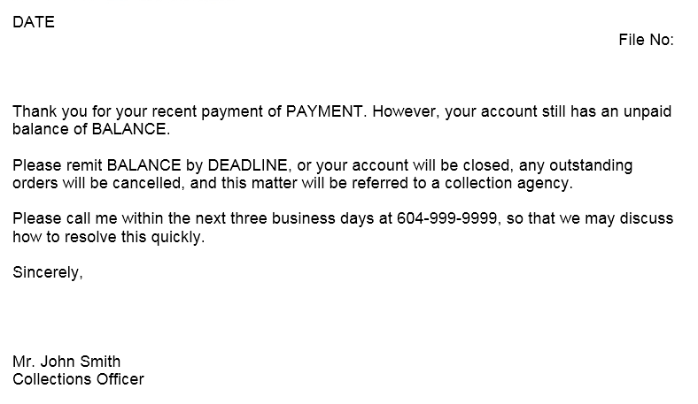
- With the document open, click the Mailings tab.
- Click Start Mail Merge following by Letters.
Associating the Data Source
- From the Mailings tab, click Select Recipients followed by Use Existing List.

- When the Select Data Source dialog box appears, navigate to the directory that contains the Word or Excel data file. Click Open.

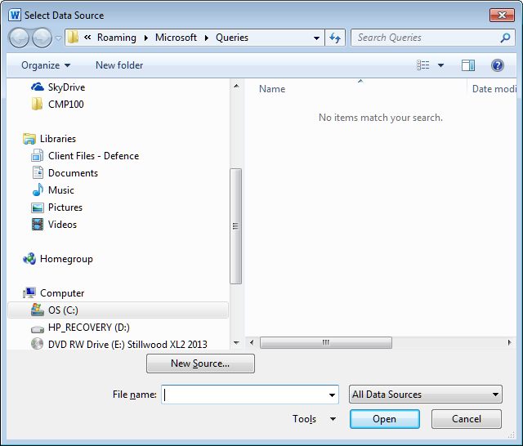
- The following dialog box will appear if the data file is an Excel spreadsheet. Note the name of the table corresponds to the worksheet tab name.
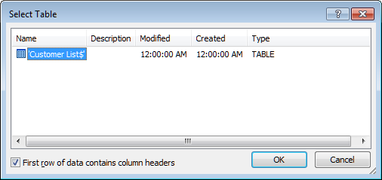
- Click OK.
- At this point it will not be obvious that the data is “attached” to your Word document.
- From the Mailings tab, click 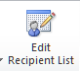 to view the data. Click OK to return to the letter.
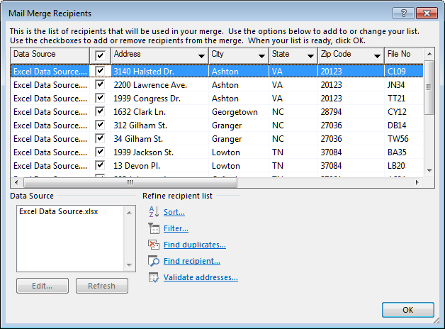
Insert Merge Fields
- The first field to insert in a letter is the date. Position the cursor at the top of the letter where you’d want the date, and from the Insert tab, in the Text group, click Date & Time.
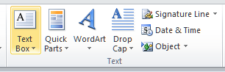
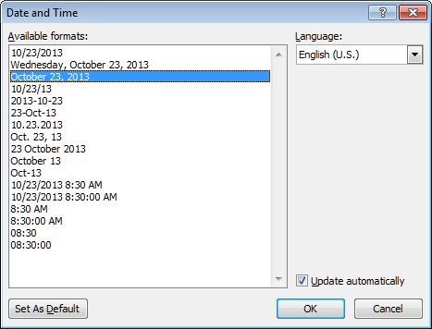
- Ensure Update automatically is checked.
- To insert the merge fields, position the cursor in the desired position in the letter, and from the Mailings tab click the bottom portion of the Insert Merge Field split button. Choose the desired field. Repeat until the fields are inserted in the appropriate locations.

- Another way of viewing the document to clearly see where the codes are is to press Alt+F9. This is a toggle keystroke that will turn the codes off or on.
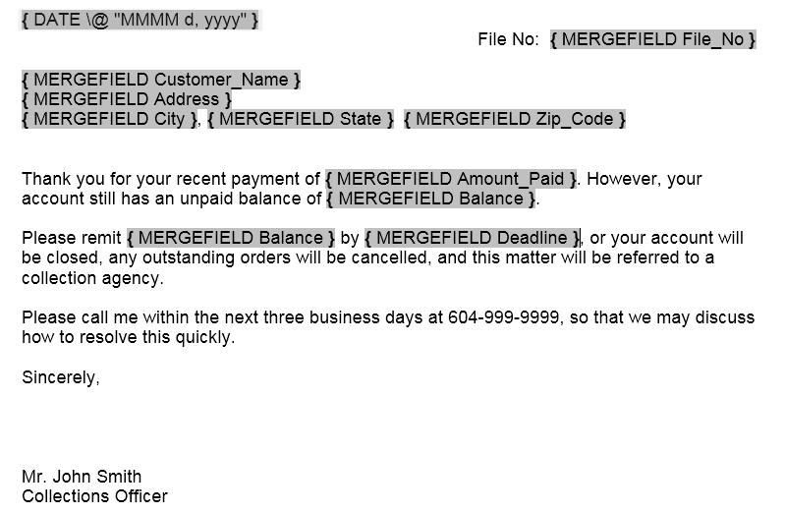
- You can preview the results before merging by clicking the Preview Results button on the toolbar and navigating through the records by clicking the arrows.
- To complete the merge, from the Mailings tab, click Finish & Merge, and choose Edit Individual Documents. This will allow you to review the letters before printing. Click OK to complete the merge.
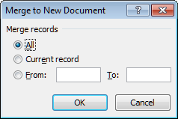
Mailing Labels
Mailing labels can easily be created from a data source as well.
- With a blank document open, click the Mailings tab.
- Click Start Mail Merge following by Labels.
Choose a desired product as shown below and click OK.
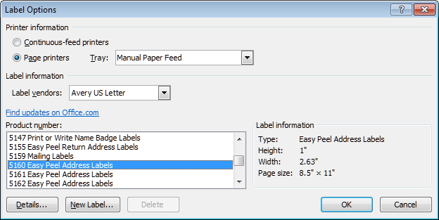
- As in the previous letter example, click Select Recipients followed by Use Existing List.

- When the Select Data Source dialog box appears, navigate to the directory that contains the data file. Click Open.
- Insert the fields in the first label, using the same method as in the previous letter example so the fields appear as follows.
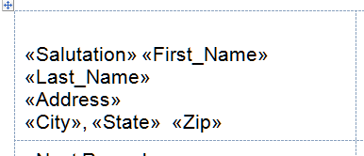
- Click the Update Labels button in the Write & Insert Fields group to duplicate the information on all the other labels.
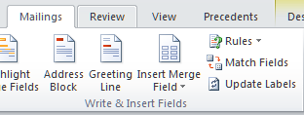
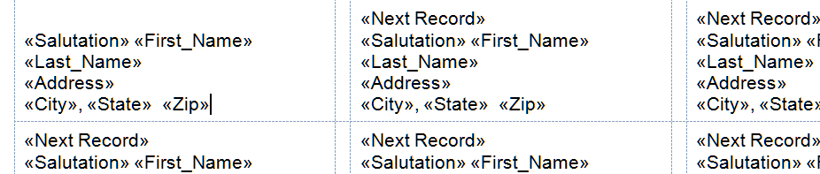
- To complete the merge click Finish & Merge and choose Edit Individual Documents. This will allow you to review the labels before printing. Click OK to complete the merge.

Format (\*) field switches
A field switch can be added to a field to control the formatted result. For example {MERGEFIELD File_No \* Upper} would result in the field being displayed in uppercase letters, in case there was an error in data entry and some had not been typed using all caps.
For Amount Paid the field could be edited to {MERGEFIELD Amount_Paid \# $###,##0.00 to display with a dollar sign and two decimals. This is necessary when merging to an Excel spreadsheet.
The deadline date format can be controlled with \@ “MMMM d, yyyy”.
Operator | Description
\* Caps | The first letter of each word would be capitalized
\* FirstCap | The first letter of the first word
\* Upper | All letters uppercase
\* Lower | All letter lowercase
\# $###,##0.00 | Displays a number with a dollar sign and comma separator if 1,000 or greater, and two decimal places.
\@ “MMMM d, yyyy” | Displays a date as January 1, 2019

For a complete list of field switches refer to the following Microsoft website:
https://support.office.com/en-us/article/format-field-results-baa61f5a-5636-4f11-ab4f-6c36ae43508c
Filtering Data Source
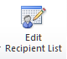
You may wish to mail only records that meet certain criteria.
- To “filter” your date source list before merging click the Edit Recipient List button.
The following dialog box will appear. Click Filter.
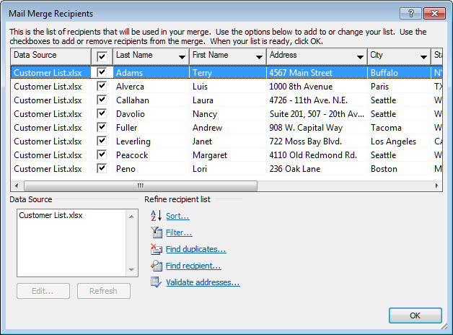
- Select the desired field to filter on in the field drop down, followed by your choice of comparison and what you are comparing to. The following example would provide you with only the records where the Balance is not 0. When you click OK, and then merge, the result would only be letters only for those customers that have a balance.
- Note: It is important to go back to the Filter and clear before attempting to merge to the complete list again.
Using If…Then…Else
“If…Then…Else” statements are a great way to further personalize a letter by creating a “condition” in which to insert certain text.
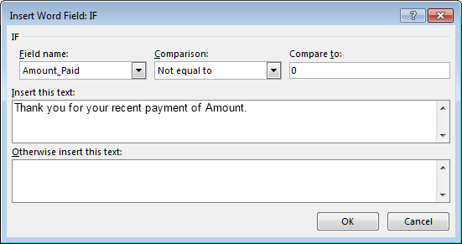
- From the Mailings tab, click Rules, followed by If…Then…Else.

The field result will be as follows:
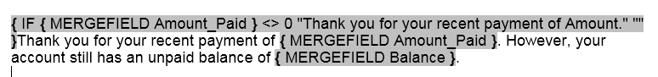
- Edit the field as follows by replacing the word Amount with the Amount Paid field and then moving the following sentence so it is within the quotes.
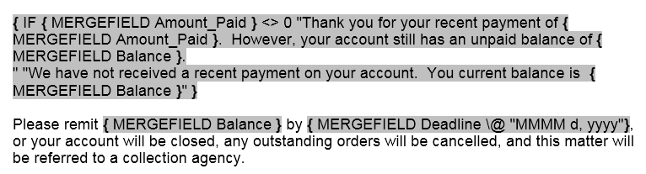
If the condition is true (i.e. Amount Paid is not equal to zero) the text will display. Otherwise, the text that follows in the second set of quotations will display.

